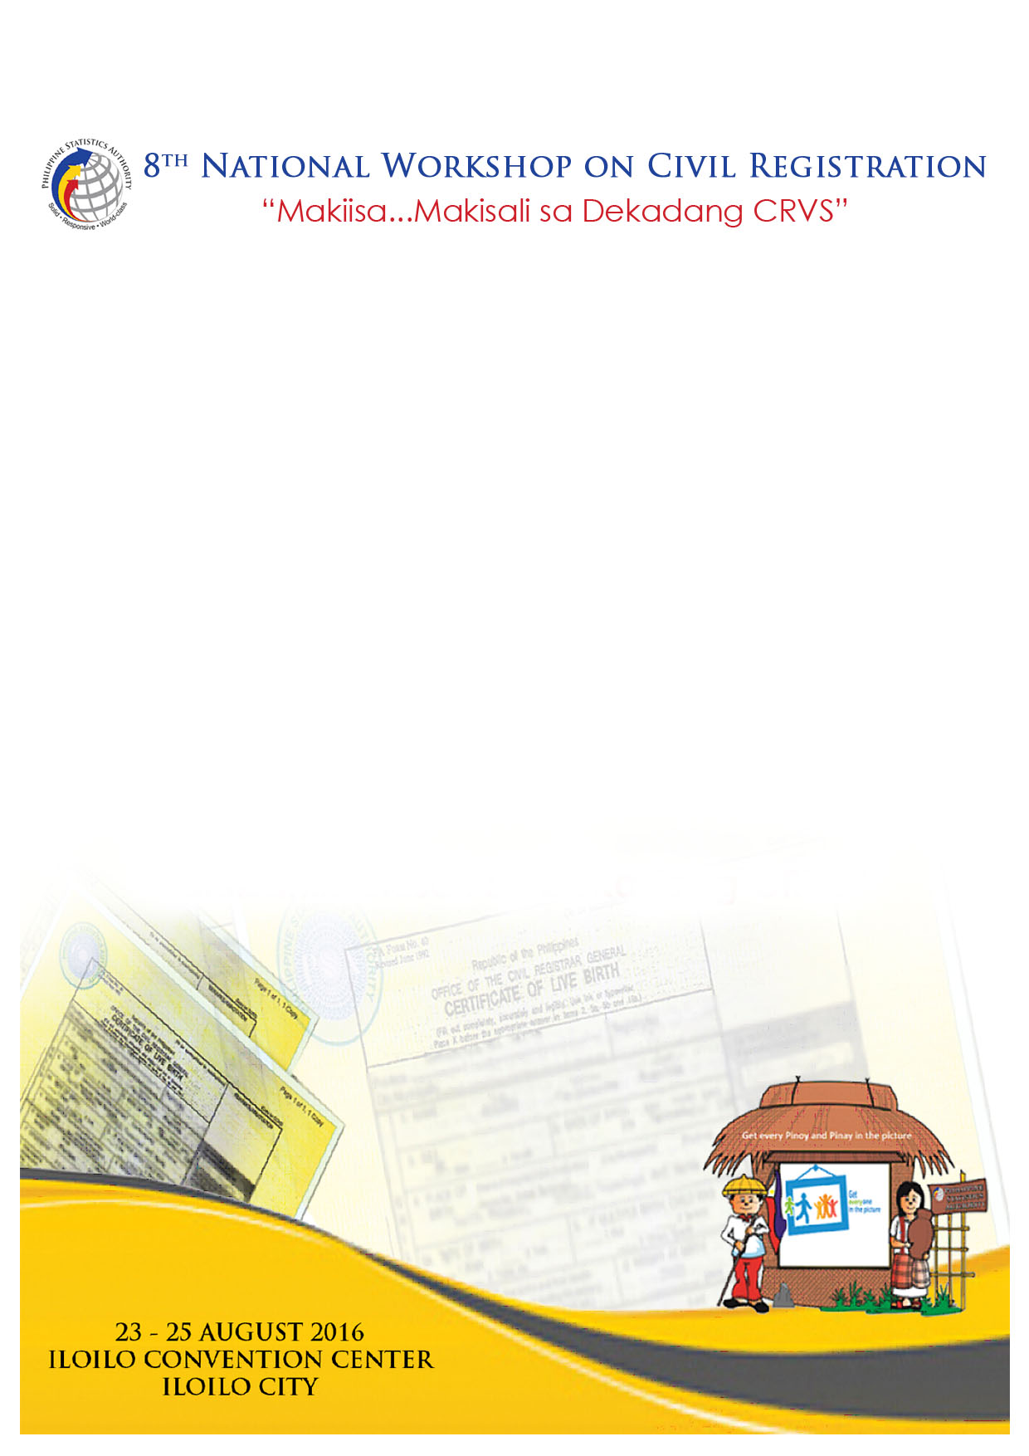

**Revised Implementing Rules and Regulations of Republic Act 9255**

Atty. Lourdines C. Dela Cruz

Director, Legal Service

Philippine Statistics Authority

**Revised Implementing Rules and Regulations of Republic Act 9255[1]**

Lourdines C. dela Cruz[2]

**INTRODUCTION**

There are different rules in making the entry of the last name of the child depending on the date of birth and whether or not the parents were married at the time of birth. If the parents are married at the time of birth, the children adopt their fathers’ surname no matter when they were born. It is when the parents are not married prior to or at the time of birth that there are various rules to be followed. In the early days, the surname to be used depends on which parent acknowledges the child. If the child is acknowledged by both parents, the child follows the father’s surname. If only one parent acknowledges, the child follows the surname of the acknowledging parent. If neither parent acknowledges the child, then the latter uses the mother’s surname. These were the guidelines being followed until the effectivity of the Family Code on 3 August 1988.

Article 176 of the Family Code provides:

*“Illegitimate children shall use the surname and shall be under the parental authority of their mother, and shall be entitled to support in conformity with this Code. The legitime of each illegitimate child shall consist of one-half of the legitime of a legitimate child.” (Underscoring ours)*

Thus, a child who was born out of wedlock adopts the mother’s surname with or without the father’s acknowledgment. In addition, these children do not have any middle name so as not to confuse them as their mothers’ siblings.

Then, Republic Act No. 9255 (RA 9255) was enacted and signed into law by President Gloria Macapagal-Arroyo on 24 February 2004. This is entitled *An Act Allowing Illegitimate Children to Use the Surname of Their Father, Amending for the Purpose Article 176 of Executive Order No. 209, Otherwise Known as the “Family Code of the Philippines.”* After publication within the required period, the law finally took effect on 19 March 2004. It aims to remove the social stigma of being an illegitimate child by giving the individual a chance to use the father’s surname despite the fact that the parents are not legally married. Article 176, as amended by RA 9255, now read as follows:

*“Illegitimate children shall use the surname and shall be under the parental authority of their mother, and shall be entitled to support in conformity with this Code. However, illegitimate children may use the surname of their father if their filiation has been expressly recognized by the father through the record of birth appearing in the civil register, or when an admission in a public document or private handwritten instrument is made by the father, Provided, the father has the right to institute an action before the regular courts to prove non-filiation during his lifetime. The legitime of each illegitimate child shall consist of one-half of the legitime of a legitimate child.” (Underscoring ours)*

The Office of the Civil Registrar General of the then National Statistics Office promulgated the Implementing Rules and Regulations (IRR) of RA 9255 on 14 May 2004. Since then, a number of individuals availed of the benefits of the provisions of this law with the father executing an Affidavit to Use Father’s Surname (AUSF). However, this procedure became controversial with the promulgation of the *en banc* decision by the Supreme Court in “Grace M. Grande versus Patricio T. Antonio”, G.R. No. 206248 on 18 February 2004.

**BACKGROUND OF THE CASE**

Petitioner, Grace M. Grande (Grande), and Respondent, Patricio T. Antonio (Antonio), were living together as husband and wife. They, however, cannot get married because Antonio is legally married to another woman. They begot two (2) children: Andre Lewis and Jerard Patrick. Andre Lewis was born on 8 February 1998. Jerard Patrick, on the other hand, was born on 13 October 1999. The two (2) children were not acknowledged by Antonio. Hence, the mother’s surname “Grande” was entered in their respective Certificates of Live Birth.

After some time, the relationship between Grande and Antonio got sour and they separated ways. Grande, together with her children, left for the United States in May 2007.

Due to this event, Antonio filed a Petition for Judicial Approval of Recognition with Prayer to take Parental Authority, Parental Physical Custody, Correction/Change of Surname of Minors and for the Issuance of Writ of Preliminary Injunction before the Regional Trial Court, Branch 8 of Aparri, Cagayan (RTC). Attached to his Petition is a notarized Deed of Voluntary Recognition of Paternity of the children.

The RTC rendered its decision on 28 September 2008 and decreed the following:

1. *Ordering the Office of the City Registrar of the City of Makati to cause the entry of the name of [Antonio] as the father of the aforementioned minors in their respective Certificate of Live Birth and causing the correction/change and/or annotation of the surnames of said minors in their Certificate of Live Birth from Grande to Antonio;*
2. *Granting [Antonio] the right to jointly exercise Parental Authority with [Grande] over the persons of their minor children, Andre Lewis Grande and Jerard Patrick Grande;*
3. *Granting [Antonio] primary right and immediate custody over the parties’ minor children Andre Lewis Grandre and Jerard Patrick Grande who shall stay with [Antonio’s] residence in the Philippines from Monday until Friday evening and to [Grande’s] custody from Saturday to Sunday evening;*
4. *Ordering [Grande] to immediately surrender the persons and custody of minors Andre Lewis Grande and Jerard Patrick Grande unto [Antonio] for the days covered by the Order;*
5. *Ordering parties to cease and desist from bringing the aforenamed minors outside of the country, without the written consent of the other and permission from the court;*
6. *Ordering parties to give and share the support of the minor children Andre Lewis Grande and Jerard Patrick Grande in the amount of ~~P~~30,000 per month at the rate of 70% for [Antonio] and 30% for [Grande].*(Emphasis supplied.)

Grande filed a Motion for Reconsideration with the RTC but it was denied. She then sought recourse with the Court of Appeals (CA). The CA partly modified the decision of the RTC. The dispositive portion of the CA Decision reads:

*WHEREFORE, the appeal is partly GRANTED. Accordingly, the appealed Decision of the Regional Trial Court Branch 8, Aparri Cagayan in SP Proc. Case No. 11-4492 is MODIFIED in part and shall hereinafter read as follows:*

1. *The Offices of the Civil Registrar General and the City Civil Registrar of Makati City are DIRECTED to enter the surname Antonio as the surname of Jerard Patrick and Andre Lewis, in their respective certificates of live birth, and record the same in the Register of Births;*
2. *[Antonio] is ORDERED to deliver the minor children Jerard Patrick and Andre Lewis to the custody of their mother herein appellant, Grace Grande who by virtue hereof is hereby awarded the full or sole custody of these minor children;*
3. *[Antonio] shall have visitorial rights at least twice a week, and may only take the children out upon the written consent of [Grande]; and,*
4. *The parties are DIRECTED to give and share in support of the minor children Jerard Patrick and Andre Lewis in the amount of ~~P~~30,000.00 per month at the rate of 70% for [Antonio] and 30% for [Grande].* (Emphasis supplied)

Grande was not satisfied with the Decision of the CA, particularly its order to change the children’s surname to that of their father which is “Antonio”. She filed a Motion for Reconsideration but the same was denied. She, then, had the case elevated to the Supreme Court alleging that *Article 176 of the Family Code––as amended by Republic Act No. (RA) 9255, couched as it is in permissive language––may not be invoked by a father to compel the use by his illegitimate children of his surname without the consent of their mother.*

**ISSUE**

*Whether or not the putative father can compel the use of his surname by his illegitimate children upon his recognition of their filiation.*

**DISCUSSION AND RULING OF THE SUPREME COURT**

***“Art. 176 gives illegitimate children the right to decide if they want to use the surname of their father or not.”***

There was no resolution as whether or not the children’s name should be changed from “Grande” to “Antonio”. But the SC made an unequivocal pronouncement as to who should decide what family name to use in case of illegitimate children. The choice lies with the children themselves based on Article 176 of the Family Code, as amended by RA 9255. The SC said:

*Now comes the matter of the change of surname of the illegitimate children. Is there a legal basis for the court a quo to order the change of the surname to that of respondent?*

*Clearly, there is none. Otherwise, the order or ruling will contravene the explicit and unequivocal provision of Art. 176 of the Family Code, as amended by RA 9255.*

*Art. 176 gives illegitimate children the right to decide if they want to use the surname of their father or not. It is not the father (herein respondent) or the mother (herein petitioner) who is granted by law the right to dictate the surname of their illegitimate children.*

*Nothing is more settled than that when the law is clear and free from ambiguity, it must be taken to mean what it says and it must be given its literal meaning free from any interpretation.**[16](http://www.lawphil.net/judjuris/juri2014/feb2014/gr_206248_2014.html" \l "fnt16) Respondent’s position that the court can order the minors to use his surname, therefore, has no legal basis.*

*On its face, Art. 176, as amended, is free from ambiguity. And where there is no ambiguity, one must abide by its words. The use of the word "may" in the provision readily shows that an acknowledged illegitimate child is under no compulsion to use the surname of his illegitimate father. The word "may" is permissive and operates to confer discretion**[17](http://www.lawphil.net/judjuris/juri2014/feb2014/gr_206248_2014.html" \l "fnt17) upon the illegitimate children.*

***“The Supreme Court has time and again, rebuffed the idea that the use of the father’s surname serves the best interest of the minor child.”***

It was noted that the CA based its decision to change the children’s surname on the universally protected "best-interest-of-the-child" clause. Nevertheless, the SC has *time and again, rebuffed the idea that the use of the father’s surname serves the best interest of the minor child.* A number of cases has already been decided to this effect, three (3) of which were mentioned in the Court’s decision in Grande vs. Antonio.

***In the Matter of the Petition for Change of Name of Maria Estrella Veronica PrimitivaDuterte, Estrella S. Alfon vs. Republic of the Philippines***

***(G. R. No. L-51201 29 May 1980)***

As mentioned in the SC’s *en banc* decision in Grande vs. Antonio:

*In Alfon v. Republic, for instance, this Court allowed even a legitimate child to continue using the surname of her mother rather than that of her legitimate father as it serves her best interest and there is no legal obstacle to prevent her from using the surname of her mother to which she is entitled.*

Petitioner was born as 15 May 1952 as Maria Estrella Veronica PrimitivaDuterte to FilomenoDuterte and Estrella Veronica PrimitivaDuterte. She was, however, taken care of by her uncle Hector Alfon for twenty-three (23) years. She used the name Estrella S. Alfon when she started schooling until she finished college. She even used the same name in exercising her right of suffrage.

The lower court denied the petition to change the surname but the SC reversed the lower court stating its reason in this manner:

*The only reason why the lower court denied the petitioner's prayer to change her surname is that as legitimate child of FilomenoDuterte and EstrellaAlfon she should principally use the surname of her father invoking Art. 364 of the Civil Code. But the word "principally" as used in the codal provision is not equivalent to "exclusively" so that there is no legal obstacle if a legitimate or legitimated child should choose to use the surname of its mother to which it is equally entitled. Moreover, this Court in Haw Liong vs. Republic, G.R. No.L-21194. April 29, 1966, 16 SCRA 677, 679, said:*

*The following may be considered, among others, as proper or reasonable causes that may warrant the grant of a petitioner for change of name; (1) when the name is ridiculous, tainted with dishonor, or is extremely difficult to write or pronounce; (2) when the request for change is a consequence of a change of' status, such as when a natural child is acknowledged or legitimated; and (3) when the change is necessary to avoid confusion Tolentino, Civil Code of the Philippines, 1953 ed., Vol. 1, p. 660).*

*In the case at bar, it has been shown that petitioner has, since childhood, borne the name Estrella S. Alfon although her birth records and baptismal certificate show otherwise; she was enrolled in the schools from the grades up to college under the name Estrella S. Alfon; all her friends call her by this name; she finished her course in Nursing in college and was graduated and given a diploma under this name; and she exercised the right of suffrage likewise under this name. There is therefore ample justification to grant fully her petition which is not whimsical but on the contrary is based on a solid and reasonable ground, i.e. to avoid confusion.*

***In the Matter of the Change of Name of Gertrudes Josefina Del Prado, thru her Natural Guardian Corazon Adolfo Calderon vs. Republic of the Philippines***

***(G. R. No. L-18127 5April 1967)***

The petitioner in this case is an illegitimate child having been born out if a bigamous marriage contracted by her parents, Manuel Del Prado and Corazon Adolfo. The mother later on married Engr. Romeo C. Calderon, and was known as Corazon Adolfo Calderon. In her petition, it was alleged that the family name “Del Prado” carries with it the stigma of illegitimacy. Thus, she prays to have the family name changed to Calderon.

The SC granted the petition.

*A petition to change the name of an infant, as in this case, should be granted only where to do so is clearly for the best interest of the child. When the mother of the petitioner filed the instant petition she had in mind what she believed was for the best interest of her child considering that her husband Romeo C. Calderon is the one supporting the child and that he is agreeable to the child's using his surname. The mother had considered the generous attitude of her husband as an opportunity for her to promote the personality, and enhance the dignity, of her daughter, by eliminating what constitutes a stigma of illegitimacy which her child would continue to bear if her surname is that of her illegitimate father.*

***Republic of the Philippines vs. Trinidad R.A. Capote***

***(G. R. No. 157043 2 February 2007)***

Giovanni N. Gallamoso is the illegitimate child of Corazon Nadores and DiosdadoGallamoso. He was born on 9 July 1982, prior the effectivity of the Family Code. His birth was registered under the provisions of the Civil Code. Consequently, his mother has Giovanni use his father’s surname.

It was alleged in the petition that *the father, DiosdadoGallamaso, from the time [Giovanni] was born and up to the present, failed to take up his responsibilities [to him] on matters of financial, physical, emotional and spiritual concerns. [Giovanni’s pleas] for attention along that line [fell] on deaf ears xxx xxxxxx.*Moreover, the child was due to be petitioned and join his mother in the United States. It is for this reason that the petition for change of family name was filed.

In this case, the SC said:

*We gave due deference to the choice of an illegitimate minor to use the surname of his mother as it would best serve his interest, thus:*

*The foregoing discussion establishes the significant connection of a person’s name to his identity, his status in relation to his parents and his successional rights as a legitimate or illegitimate child. For sure, these matters should not be taken lightly as to deprive those who may, in any way, be affected by the right to present evidence in favor of or against such change.*

*The law and facts obtaining here favor Giovanni’s petition. Giovanni availed of the proper remedy, a petition for change of name under Rule 103 of the Rules of Court, and complied with all the procedural requirements. After hearing, the trial court found (and the appellate court affirmed) that the evidence presented during the hearing of Giovanni’s petition sufficiently established that, under Art. 176 of the Civil Code, Giovanni is entitled to change his name as he was never recognized by his father while his mother has always recognized him as her child. A change of name will erase the impression that he was ever recognized by his father. It is also to his best interest as it will facilitate his mother’s intended petition to have him join her in the United States. This Court will not stand in the way of the reunification of mother and son.*

***“The implementing rules and regulations of a law cannot extend the law or expand its coverage, as the power to amend or repeal a statute is vested in the Legislature.”***

In discussing the proper application of Article 176 of the Family Code, as amended by RA 9255, the SC had the opportunity to review Rules 7 and 8 of the OCRG Administrative Order No. 1, series of 2004 which was then Implementing Rules and Regulations (IRR) of RA 9255.

Rules 7 and 8 of the IRR used the word “shall” as opposed to the clear and unequivocal use of the word “may” in Article 176 of the Family Code as amended. The former makes the use of surname of the father by an illegitimate child mandatory; whereas, the use of “may” under the law grants the child an option whether or not to use the surname of the father. In case of conflicts such as these, the basic rule is that an administrative issuance, like the IRR, cannot amend a legislative act such as RA 9255.

**CONCLUSION**

Based on the foregoing discussion, the SC held that the choice of which surname to use lies with the illegitimate child. This is clearly stated under Art. 176 of the New Civil Code, as amended by RA 9255. Thus, Rules 7 and 8 of the IRR were declared null and void because it runs counter with the law it implements.

1. Paper presented during the 8th National Workshop on Civil Registration held at Iloilo Convention Center, Iloilo City
2. Director, Legal Service, PSA