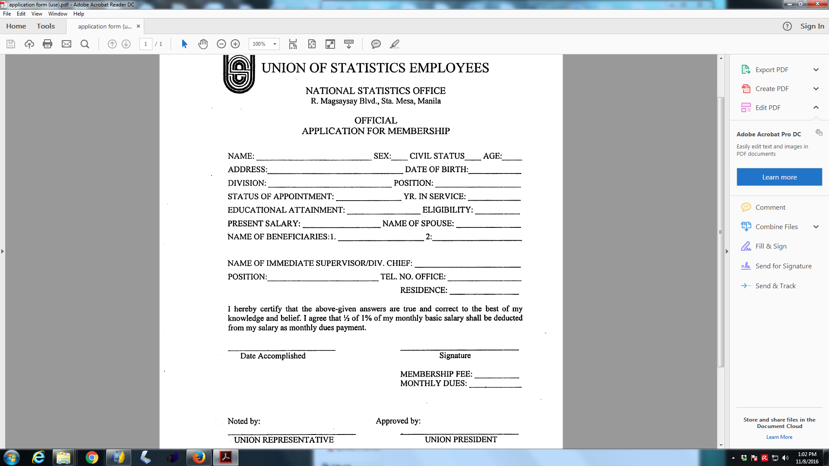

**PHILIPPINE STATISTICS AUTHORITY**