MARCH 29, 2019

W/N PHILIPPINES

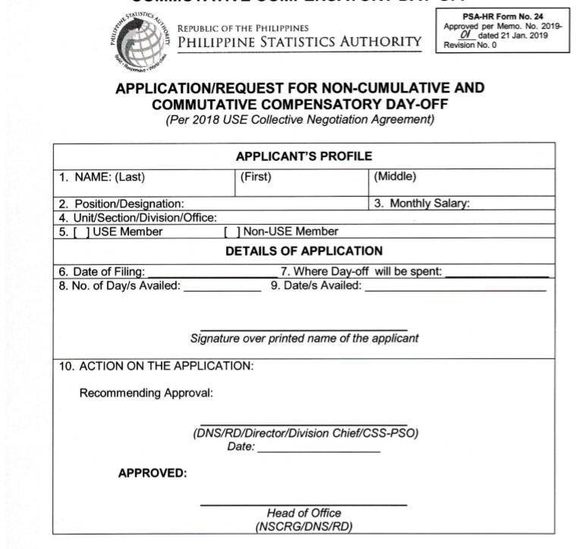

SURENAME

FIRSTNAME

MIDDLENAME

POSITION

Php 00,000.00

ANTIQUE PSO

/ PSO

MARCH 29, 2019

2.0

APRIL 10-11, 2019

RANDY M. TACOGDOY

ARNOLD D. PERNIA  
SS II, USE CHAPTER PRESIDENT

JESUS F. ESCOTE, JR.  
PROVINCIAL STATISTICS OFFICER

W/N PHILIPPINES