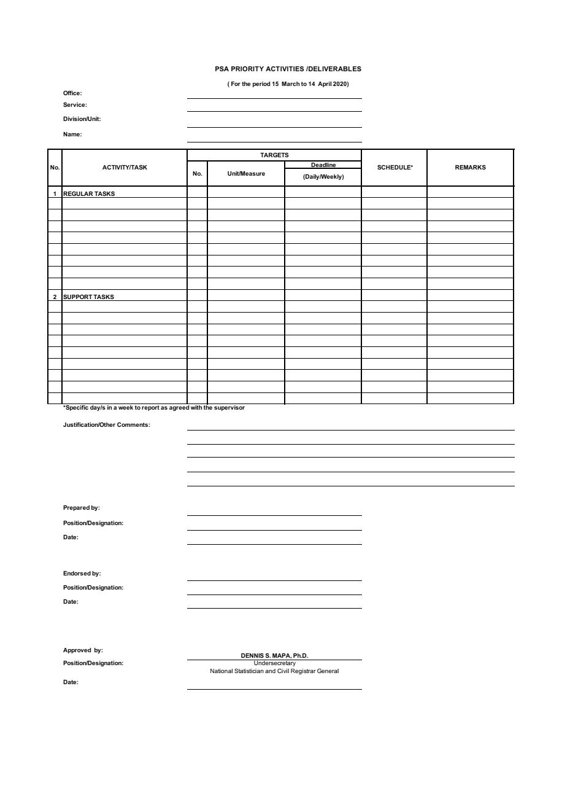

____________MARLENE Y. ALVIAR____________

_______CSS, Officer-in-Charge, RSSO VI________

(For the period 01 April to 30 April 2020)

RSSO VI

Antique PSO

Philippine Statistics Authority

Randy M. Tacogdoy

2020 CPH Maps Printing

Map/Page

100% Accomplished

April 8 and 16

April 2020 LFS 2nd Lvl Training

Training

100% Attended (on-line)

April 2020 LFS 3rd Lvl Training

Training

April 21, 2020

100% Conducted

Updating of Website and FB

PCNR Preparation/Finalization

Updates/Items

Report

April 20, 2020

April 20, 2020

April 2020 LFS Supervision

EA

April 22-30, 2020

100% Accomplished

100% Accomplished

100% Conducted

Weekly

JESUS F. ESCOTE, JR.

Provincial Statistics Officer

May 12, 2020

RANDY M. TACOGDOY

Supervising Statistical Specialist

May 12, 2020

9

1

1

1

5

April 17, 2020

1,714